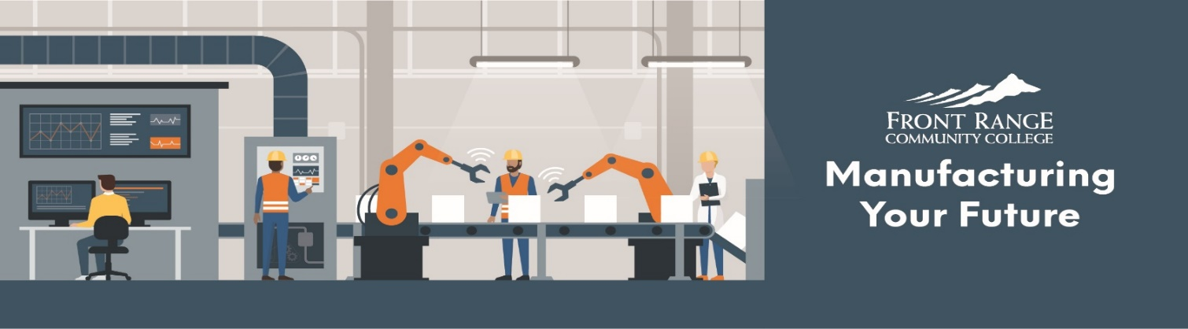

It’s a game changer. Within two years of starting their machining program, 10 percent of our workforce came out of the FRCC program.”
- Pete Neidecker,
Former President and CEO of Mountainside Medical Systems

Skilled Workers are in Demand
In 2013, Front Range Community College responded to industry’s need for more machinists and manufacturing technicians. The college started the Precision Machining Technology program at the Boulder County Campus. It modified the Clean Energy Program at the Larimer Campus to align with industry skill requirements.
Since then, the demand for trained manufacturing workers continues to grow. Additional programs are needed.

Manufacturing is Vital for the Health of Colorado’s Economy
Almost 6,000 manufacturers operate in Colorado. They employ 5.5 percent of the state's workforce. They account for 93 percent of Colorado's exports and 7.3 percent of Colorado's GDP. The shortage of trained manufacturing workers is the single greatest threat to Colorado’s vital manufacturing industry.

Our Commitment

FRCC has committed $6.2 million to create a Center for Integrated Manufacturing (CIM) in Longmont, which will expand training options for Colorado’s manufacturing industry. Longmont is centrally located within FRCC's service area. The CIM will serve businesses and students from Westminster to Wellington. FRCC’s plan is to start—or expand—the following programs at the CIM:
- Automation and Engineering Technology (New)
- Electronics and Engineering Technology (New)
- Optics Technology (Opened January 2018)
- Precision Machining (Existing program)

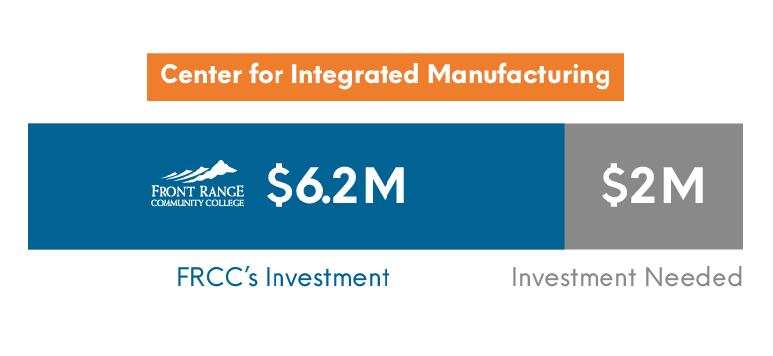
Naming Opportunities
Naming of Lab Space $250,000 (3 available)
- Optics Lab
- Electronics Lab Advanced Energy Lab of Electronics
- Automation and Engineering Tech Lab
- Machining Lab

Conference Room $50,000 Boulder Community Foundation
Naming of Classroom $35,000 (6 available)
Student Locker area $25,000 (1 available)
Faculty Workroom $20,000 (1 available)
Tool Crib $15,000 (1 available)
Faculty Office $10,000 (7 available)

