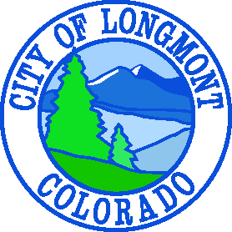

CITY COUNCIL AGENDA

Friday, January 4, 2019

Front Range Community College,
2120 Miller Dr. Longmont, CO 80501

08:30 AM – City Council Work Session

MEETING CALLED TO ORDER

1. ROLL CALL
2. BOARD AND COMMISSION UPDATES
3. DISCUSSION ITEMS
A. Front Range Community College Tour And Update
8:30 – 8:50 – Meet At The Advanced Technology Center 2120 Miller Dr. For A Tour Of The Machining Program
9:00 – 9:45—Gather At The 'A' Building 2150 Miller Dr., Room A1222 For The Remainder Of The Meeting
1. The Opening Of The Center For Integrated Manufacturing In Fall Of 2019.
2. Next Steps In Planning For A Permanent FRCC Boulder County Campus.
B. Discussion And Presentation Of St. Vrain River Corridor By Shari Malloy - 10 Minute Presentation, 35 Minute Discussion
C. Council Work Plan Updates
4. DETERMINE TOPIC OF NEXT WORK SESSION
5. ADJOURN

