Esta carta se refiere al Proyecto de Mejoras para Pike Road que comenzará a construirse en marzo. Si necesita esta información en español, por favor llame al (303) 651-8416 o vea el texto de la carta en http://bit.ly/pike-road-spanish-feb-2020
Dear Resident,
Pike Road from S. Main Street (US-287) to S. Sunset Street is scheduled to receive several safety and multimodal transportation improvements starting in March 2020. These improvements are outlined below. Planned improvements are in alignment with multiple guiding principles of the Envision Longmont Multimodal & Comprehensive Plan. Additionally, public feedback sought in 2019 has been incorporated into the project where possible.
Incorporation of Community Feedback
Neighborhoods in the project vicinity were invited to learn more about, and comment on, the project at two public meetings in February 2019. Feedback was gathered through question and answer sessions, completion of comment cards and an opportunity to write comments on project plans. Feedback focused primarily on concerns with traffic speeding, high traffic volumes, pedestrian access and removal of trees. City staff evaluated this feedback, and the following changes to the project were made to address these concerns:
- Addition of a traffic signal at S. Coffman Street and Pike Road
- Addition of radar speed display signs for eastbound and westbound Pike Road
- Reduction of travel lane widths to promote vehicle adherence to posted speed limits
- Shifting the planned sidewalk north of Pike Road to the south to provide a larger buffer area between the sidewalk and properties
- Minor modifications to the planned raised median at Kristy Court to make turning west onto Pike Road easier
- Planting of trees along Pike Road following the completion of the project. In the meantime, the project is making a payment to a city-managed tree-planting fund in an amount equivalent to the assessed value of the removed trees.
Planned Improvements – Additional project details can be found at http://bit.ly/Pike-Road-Improvements
- Traffic Calming Roadway Elements – Various traffic calming features will be installed, such as travel lane width reductions, raised medians and radar speed display signs.
- Bike and Pedestrian Improvements – Pike Road will receive minor roadway widening to support the addition of on-street bike lanes. Additionally, a detached sidewalk will be installed north of Pike Road from S. Sunset Street to the Left Hand Creek underpass and from S. Coffman Street to S. Main Street. Raised pedestrian refuge islands will be installed at various locations to provide safer crossing of Pike Road and cross-streets.
- Intersection Safety Improvements – The intersection of S. Pratt Parkway at Pike Road will be reconstructed to eliminate the skew approach, so vehicles approaching Pike Road will enter the intersection at more of a perpendicular angle. Left-turn lanes will be installed on Pike Road at S. Coffman Street to allow for through traffic to pass safely by turning traffic. Also, a new traffic signal will be installed at S. Coffman Street.
Additionally, this project includes installation of a second westbound travel lane on Pike Road from S. Main Street to S. Coffman Street. This additional travel lane is required to accommodate an additional left-turn lane for northbound S. Main Street to westbound Pike Road. The addition of a second left-turn lane for northbound S. Main Street is a Colorado Department of Transportation (CDOT) project required to mitigate a high frequency of broadside collision accidents with vehicles making this left turn. Further details about this and other CDOT projects can be found at http://bit.ly/CDOT-projects-on-main.
- Asphalt and Concrete Repairs – Asphalt and concrete pavement repairs will be performed to rehabilitate the aging pavement infrastructure and improve road surface conditions. Further details about street rehabilitation can be found at LongmontColorado.gov/pmp.
- The following map provides a visual representation of planned improvements:
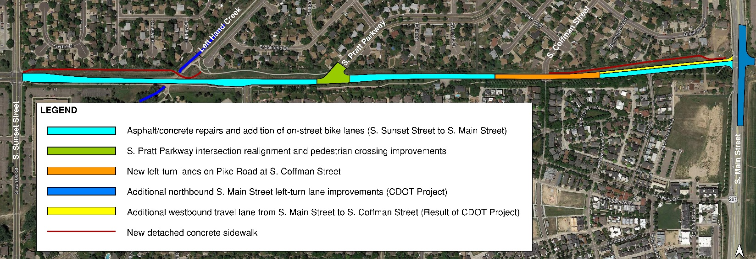
Pike Road – Planned Improvements

Project Schedule and Impacts
Construction is expected to begin in March 2020. Prior to the start of work, notice will be provided on roadside message boards placed along Pike Road. The project is expected to last for approximately seven months, barring unforeseen circumstances.
Construction will be phased to limit vehicle impacts as much as practical, but delays should be expected. No full road closures are anticipated at this time. However, there will be regular closures of either the east or westbound lanes due to the narrow pavement width of Pike Road. During those times, only one lane of traffic in one direction will be allowed to pass. Detour signs will direct vehicles traveling in the opposite direction to alternate routes, as necessary. The public is encouraged to check the project website for updates on any anticipated closures and detours.
Public Outreach & Communication Methods
In addition to this letter, the following methods of outreach and communication will be used with this project:

- Issuance of press releases to local media to announce the start of the project, as well as construction activities that significantly impact the public
- Project website updates reflecting construction progress and milestones
- Creation of a dedicated project “hotline” and email address that will be managed by a dedicated Public Information Manager
- Placement of onsite project signage advertising the project “hotline” phone number
- Use of onsite portable message boards that advertise dates of significant construction activities
For more information, please visit http://bit.ly/Pike-Road-Improvements. Questions and concerns about the project should be directed to the Public Information Officer at (720) 526-2044 or email PikeImprovements@gmail.com.
Best regards,

Alden Jenkins
City of Longmont
Senior Civil Engineer

